Tight Coupling

📌 Definition:
# Source: AI Source: Provided by: [Data Path: Persons Table -> ID Column: 1, Name_En Column: Motasem Essam] -> From: [Chatgpt (GPT‑5 Mini)] on [12/9/2025]
Tight Coupling occurs when classes or modules are highly dependent on each other, so changes in one module may require changes in the other.

🧠 Simple idea:
# Source: AI Source: Provided by: [Data Path: Persons Table -> ID Column: 1, Name_En Column: Motasem Essam] -> From: [Chatgpt (GPT‑5 Mini)] on [12/9/2025]
“Everything is connected too closely” 🔗

🔍 Key characteristics:
# Source: AI Source: Provided by: [Data Path: Persons Table -> ID Column: 1, Name_En Column: Motasem Essam] -> From: [Chatgpt (GPT‑5 Mini)] on [12/9/2025]
- One class knows too much about another class’s internal details
- ❌ Difficult to maintain and test
- ❌ Reduces reusability
- ❌ Increases the chance of errors when changing code

📊 Example:
# Source: AI Source: Provided by: [Data Path: Persons Table -> ID Column: 1, Name_En Column: Motasem Essam] -> From: [Chatgpt (GPT‑5 Mini)] on [12/9/2025]
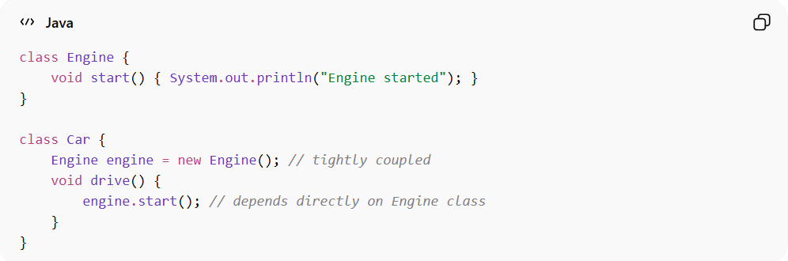
class Engine {
void start() { System.out.println("Engine started"); }
}

class Car {
Engine engine = new Engine(); // tightly coupled
void drive() {
engine.start(); // depends directly on Engine class
}
}
- ✅ Here, Car is tightly coupled with Engine. Any change in Engine may affect Car.

⚙️ Best practice:
# Source: AI Source: Provided by: [Data Path: Persons Table -> ID Column: 1, Name_En Column: Motasem Essam] -> From: [Chatgpt (GPT‑5 Mini)] on [12/9/2025]
- Reduce tight coupling using interfaces, abstractions, or dependency injection
- Aim for loose coupling whenever possible

